POS On-Us Transaction Flow
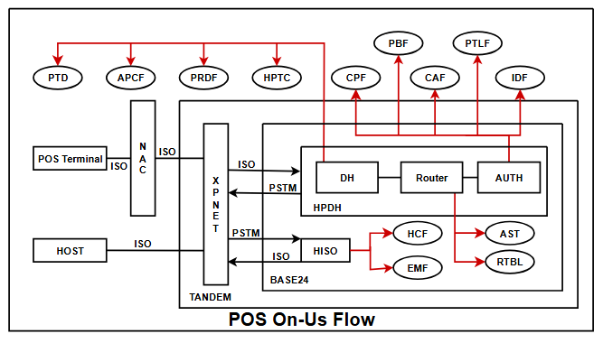
1.The transaction takes place at POS terminal then POS sends the request to HPDH through NAC (Network Access Control). The POS sends the request message in ISO form to HPDH through NAC and then via XPNET.

2.HPDH means Hypercom Device Handler and it consists of three modules i.e DH, ROUTER and AUTH. DH first reads the PTD (POS terminal data) file which contains:-
i) Terminal information i.e location, type, owner, city. It also shows retailer group, routing group, Retailer id for PRDF, Term group for HPTC.
ii)It also gives Acquirer transaction profile, which helps to read APCF and
determines which types of transaction are allowed at a particular terminal.

3.By using term group as prikey, it reads the HPTC file for terminal configuration. It card table, issuer table, acquirer table.

4.DH reads the PRDF (POS retailer definition file) file using retailer ID as prikey :-It shows all the retailer details i.e retailer name address, city, state etc. and checks the routing group.

5.The ISO messages are converted to PSTM (POS standard internal message) and request is send to router module.

6.The Router module determines the appropriate authorizer using the Authorization Selection Table ( AST ) file and the Routing Table ( RTBL ) file.

7.The authorizer names and their assign authorizer codes are named in the RTBL by institutions

8.So, after accessing the AST to determine routing parameters and authorization codes, the Router module then accesses the RTBL to determine the corresponding authorization name for the code obtained.

9.The transaction is then routed to the appropriate authorizer module by the Router Module.

10.The transaction is then forwarded to Auth module which checks the CPF file. If BIN is present in CPF, the CPF file is read by using PREFIX no and PAN length.

11.It contains general information about card and gives FIID.

12.By using FIID AUTH reads the IDF file:-
a)IT gives Path for CAF and PBF.
b)Prescreening checks are made before sending the transaction to host. Checks if host is online, maximum pin tries, bad pin action.
c)We also get POS routing table, through which we get HISO process name and DPC no
d)It also shows acquirer transaction profile name and issuer transaction profile name for POS.

13.By using FIID and PAN length as prikey the AUTH reads the CAF file,
a)It shows the card status and also the expiration date.
b)It shows multiple account for individual card holder.

14.PBF file displays various balance and amount. The prikey’s used for PBF are FIID, account type and account number

15.AUTH sends the request message to respective HISO obtained in routing table from IDF file and sets the timer. By using HISO process name and DPC no as prikey HISO reads the HCF file. From HCF file

a)It shows timer limits for POS messages
b)It also displays Station name associated with each DPC no. Station is a physical point in BASE 24 system that is designated to send and receive messages.

16.In EMF file, it contains 128 data elements i.e bit maps of which some are mandatory and some are conditional. It depends on the message type.

17.By using station name HISO sends the request to HOST and sets the timer. The messages send by HISO are in ISO format.

18.The host approves the request and sends the response to HISO. The HISO then reformats the message ISO to PSTM form and deletes the timer.

19.The HISO sends the response message to AUTH. The AUTH then updates the PTLF file and sends the response to DH through Router

20.HPDH then deletes the authorization timer and reformats the PSTM messages to ISO and sends the response to POS.

21.POS then sends the ISO message to HPDH that the transaction is completed and it is ready for next transaction.

